**Online procedural texture sharing sysTEm**

A PROJECT REPORT SUBMITTED BY

L.M Senanayake (S/15/418)

to the Board of Study in Statistics and Computer Science of the

**DEPARTMENT OF STATISTICS AND COMPUTER SCIENCE**

*in partial fulfillment of the requirement*

*for the award of the degree of*

**B.Sc. (Honours) in Computer Science**

of the

**UNIVERSITY OF PERADENIYA**

**SRI LANKA**

**2020**

# DECLARATION

I do hereby declare that the work reported in this project report was exclusively carried out by me under the supervision of Dr. Hakeem Usoof. It describes the results of my own independent work except where due reference has been made in the text. No part of this project report has been submitted earlier or concurrently for the same or any other degree.

Date: ……………………. ……………………………………………………….

Signature of the Candidate

Certified by:

1.Supervisor: Dr. Hakeem Usoof

Date: ……………………. Signature: …………………………………………….

2. Head of the Department: Dr. Ruwan Nawarathne

Date: ……………………. Signature: …………………………………………….

**Department Stamp:**

# ABSTRACT

**ONLINE PROCEDURAL TEXTURE SHARING SYSTEM**

L.M Senanayke (S/15/418)

Department of Statistics and Computer Science, University of Peradeniya,

Peradeniya, Sri Lanka

Material Designer is a texture designer with online capabilities that can be used to share procedurally designed textures via the internet among other users and also to use in games. One of the disadvantages of existing systems is that they don’t have online capabilities to serve files over the internet. Game Developers or artists will register into the system from which they can create and save their projects on the server and share among other game developers or artists. This Online Procedural Texture Sharing System is called “Material Designer” and there are 4 main parts to it. Such as Material Designer Editor, the tool that can be used to create procedural textures and upload them, Material Designer Web which is the website that can be used to share the content that the user has been created. Material Designer Server, the server that connects all the parts of the Material Designer together and the Material Designer Content Delivery Network, which can be used to serve those creations to integrate with games. Material Designer Server was implemented using microservices architecture to make the service scalable according to user needs.

# ACKNOWLEDGEMENT

Its always a pleasure to remind my supervisor Dr. Hakeem Usoof for his continuous guidance, support and constructive feedback throughout the year. I would like to thank Dr. R. Nawarathne, the head of the Department of Statistics and Computer Science for providing all the instructions and supporting us to successfully complete the project.

Further, I would like to thank Mr. P. Gunathilake, the main coordinator of the course for supporting by giving all the necessary details regarding the project throughout the year. Also, I would like to thank my parents for giving encouragement, enthusiasm and invaluable assistance to me.

My sincere gratitude goes to the Department of Statistics and Computer Science for giving me this opportunity to reach into the depths of the field of Computer Science. It has been a great achievement for me and my career ahead.

Finally, I apologize to all other unnamed who helped me in various ways to complete this project.

# **TABLE OF CONTENTS**

DECLARATION i

ABSTRACT ii

ACKNOWLEDGEMENT iii

TABLE OF CONTENTS iv

LIST OF FIGURES vii

LIST OF ABBREVIATIONS viii

CHAPTER 1 1

INTRODUCTION 1

1.1 Problem Statements 1

1.2 Objectives 2

1.3 Approach 2

1.4 Advantages Of Proposed System 3

1.5 Limitations of the current system 3

CHAPTER 2 4

BACKGROUND 4

2.1 Existing Systems 4

2.2 Limitations of existing systems 6

CHAPTER 3 7

LITERATURE REVIEW 7

3.1 PBR Workflow of texture design 7

3.2 Visual Programming 8

3.3 Node Based programming 8

3.4 Persisting user-created projects online 8

CHAPTER 4 9

METHODOLOGY 9

4.1 Overview 9

4.1.1 Editor Service 10

4.1.2 Web Service 10

4.1.4 User Service 10

4.1.5 Data Service 10

4.2 Requirement Analysis 11

4.2.1 Use Cases 11

4.3 Design 12

4.3.1 Class Diagram 12

4.3.1 Package Diagram 13

4.3.3 Development Environment 13

4.4 Testing Environment 15

4.5 System security implementation 15

4.5.1 Session management using JWT 15

4.5.2 API keys for API endpoints 15

4.5.3 Secure Keys 15

4.5.4. Password Encryption 15

4.5.4 Client and Server-side validation 16

CHAPTER 5 17

RESULTS AND DISCUSSIONS 17

5.1 System Modules 17

5.1 User Interfaces 17

5.1.1 Create cloud projects 17

5.1.2 Homepage 18

5.1.3 Download Page 19

5.1.4 Material Viewer 20

5.1.5 Material Designer Editor Software 20

5.1.6 Uploading Artwork / Projects Interface 21

5.1.7 API Keys Manager 22

5.1.8 User Login 23

5.1.9 Signup Interface 23

5.1.10 Export Material Interface 24

5.1.11 Editor Login 25

CHAPTER 6 26

CONCLUSION 26

CHAPTER 7 27

FUTURE WORK 27

7.1 Future Developments 27

REFERENCES 28

APPENDIX 29

# LIST OF FIGURES

Figure 2. 1 Substance Designer Editor 4

Figure 2. 2 Substance Alchemist 5

Figure 2. 3 Quixel Mixer Megascans Website 5

Figure 3. 1 PBR Material Textures 7

Figure 4. 1 Server Microservices Diagram 9

Figure 4. 2 Use case diagram of the server 11

Figure 4. 3 Class diagram of the Material Designer server 12

Figure 4. 4 Package Diagram of Material Designer Server 13

Figure 5. 1 Loading and creating new cloud project files interface 17

Figure 5. 2 Homepage screen capture 18

Figure 5. 3 Download page 19

Figure 5. 4 Material Viewer UI 20

Figure 5. 5 Material Designer Editor UI 20

Figure 5. 6 Uploading artwork interface 21

Figure 5. 7 API Keys manager UI 22

Figure 5. 8 Sign in interface 23

Figure 5. 9 Signup Interface 23

Figure 5. 10 Export Material Interface 24

Figure 5. 11 Sign in to editor interface 25

Figure 7. 1 Keybindings Interface 27

# LIST OF ABBREVIATIONS

API: application program interface 1

CPU: Central Processing Unit 3

GPU: Graphics Processing Unit 3

JSON: JavaScript Object Notation 1

JWT: JSON Web Token 10

# 

# INTRODUCTION

## **Problem Statements**

In computing, procedural generation is a method of creating data algorithmically as opposed to manually, typically through a combination of human-generated assets and algorithms coupled with computer-generated randomness and processing power. In computer graphics, it is commonly used to create textures and 3D models. In video games, it is used to automatically create large amounts of content in a game. The advantages of procedural generation include smaller file sizes.

In computer graphics, a procedural texture is a texture created using a mathematical algorithm rather than directly stored data. The advantage of this approach is low storage cost, unlimited texture resolution, and easy texture mapping.

In this project, procedural textures are stored as JSON objects so that those files can be shared via the internet and also can be saved in a database. These files can be created using the editor with internet capabilities called Material Designer Editor.

Instead of creating an image by defining a large, unchanging block of pixels, procedurals create the texture from the ground up. The texture is defined only by the procedure needed to create it. The User only needs to give the computer a (relatively) small formula, instead of a huge block of pixels. With this formula, the computer is able to create the texture at any scale, in any orientation, extending as far as user need. There are a few software that has the capability to do these procedures, but here this system can host these files online and share them among other users. Also, an API endpoint can be used to share these files among other applications to use in them.

This material designer software uses a visual node-based software to create files that can be shared via the internet. Generally, artists and designers will have a much easier time understanding and using a visual node-based scripting language than they would a text-based one. And due to the fact, the users of this software are mostly artists and designers, node-based language to create procedural content will aid them immensely.

## Objectives

1. Creating software that is capable of creating procedural textures from mathematical functionalities and a system to save them as JSON objects.
2. Creating a platform that allows storing these JSON files to use in other projects.
3. Making a platform to share the creations using the system among other users.
4. Creating a server that can scale up and also scale down according to the user demand overtime without any code modifications.
5. Creating the server with technologies that can be deployed in any Kubernetes supported platform without any configurations.
6. Creating a platform that users can interact in real-time without lag, so that they can work online without using any local files.
7. Allowing artists to share their work created using this system and making a social media platform to comment and like those creations.
8. Motivating graphic designers and game developers to use procedural systems.

## Approach

The proposed system is consists of four main components, a website, software, a server, and a CDN. The software mentioned above can create and upload files that generated using mathematical functions and the parameters used. The server intercepts these files and saves them in a database. And when someone requires that file using the website or the CDN the files will be served by the server. Game developers and graphic artists can use this system to use them in games, 3D renders and also other graphic related projects. And the file size of these project files are very small than a traditional texture file which can be used as a content sharing system.

## Advantages Of Proposed System

1. Can be used as a lightweight texture content delivery system instead of textures for online games.
2. Can cut down the size of online games and also the patches for online games.
3. Provides a secure platform to work on projects online without any lag.
4. Allows registered customers to save share and like and comment on their work.
5. Users can sell and share their projects via the internet without any physical interaction.
6. API can be used in any project and can be secured with client API keys.
7. Company accounts can be used to share and work as teams among their employees.

## Limitations of the current system

1. Users with low bandwidth won't be able to use the system.
2. Uses more CPU and GPU than traditional texture delivery systems.
3. Low-end computers will take a long time to process these files.
4. The software requires a lot of CPU and GPU power.
5. Most game developers still use traditional systems rather than procedural texture systems.

# 

# BACKGROUND

## Existing Systems

There are several procedural texturing software but none of them have capabilities to deliver these products (procedural texture files) via the internet as common JSON files or to have API endpoints. Though they have online libraries, users need to download these files and manually need to integrate them into their projects. But in the proposed system, users can load projects by a few mouse clicks.

[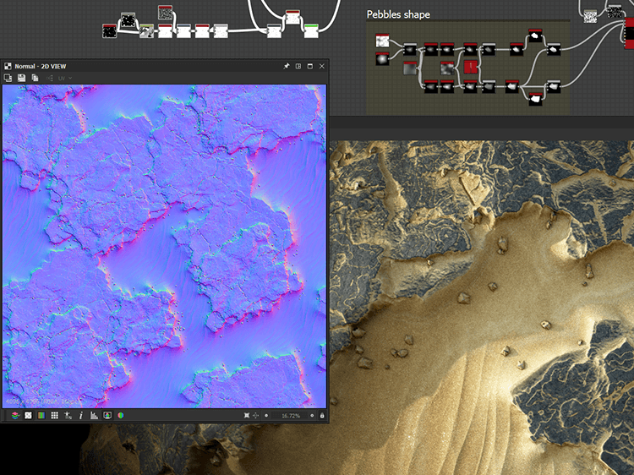](https://www.substance3d.com/products/substance-designer/)

Figure 2. 1 Substance Designer Editor

These systems don’t have online capabilities rather than downloading projects, to integrate users have to integrate them manually by downloading and then opening.

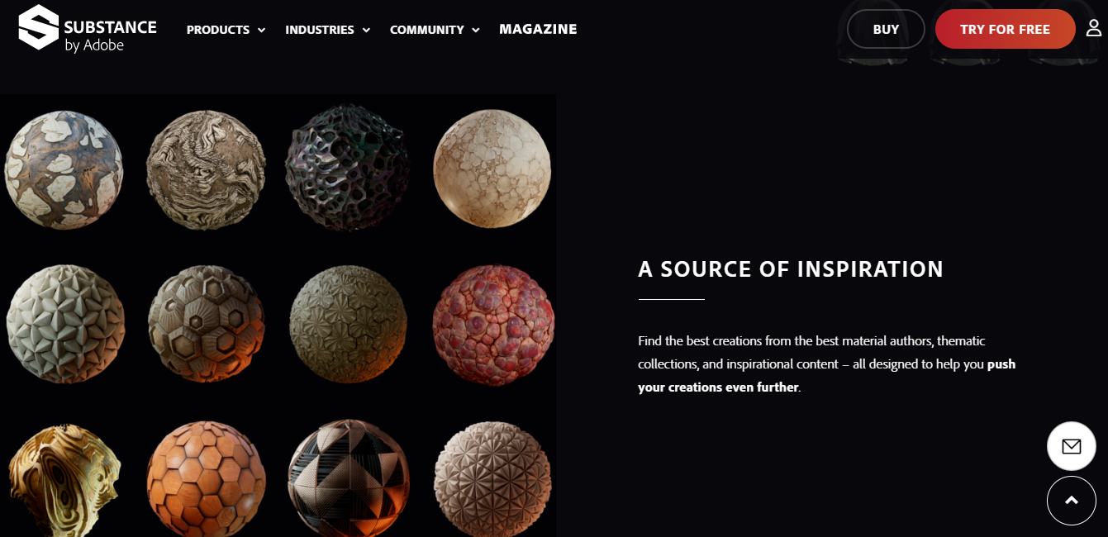

Figure 2. 2 Substance Alchemist

Though there is some texture delivering and editing systems with online capabilities, they don’t use procedural textures as delivering systems. So even the user still has texture delivering systems to use in their projects, they still will be using larger files such as JPEG or PNG as their file types for delivering texture data.

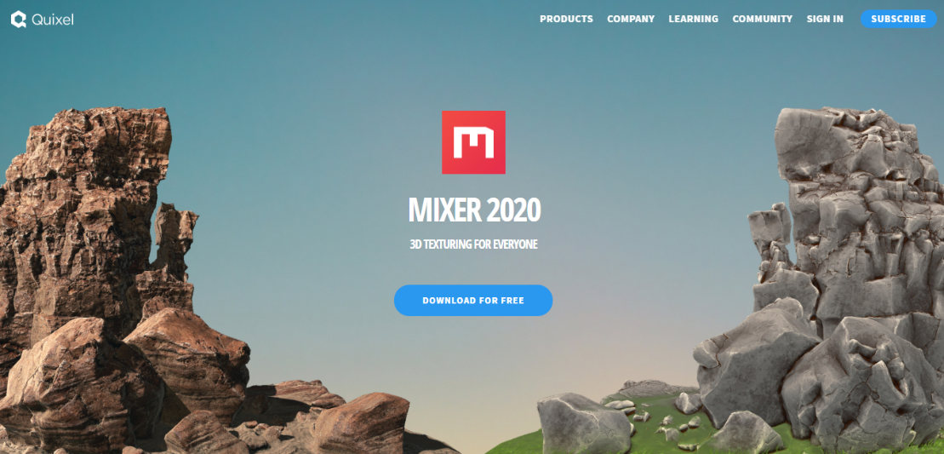

Figure 2. 3 Quixel Mixer Megascans Website

## Limitations of existing systems

1. Most software doesn’t support online texture sharing, users need to manually download and use those files.
2. Some systems don’t support procedural textures, those systems act like normal image delivery systems that are not that compatible with online games.
3. Most of those services are very expensive and not beginner-friendly, some software offer trial periods but they are very short which is not enough to grasp the functionality of the software and users need to buy that software even to just try or use as a hobby.
4. Most software is heavily outdated and not maintained so that its hard to use that software.
5. There doesn’t exist any software that has internet capabilities and also supports procedural texture generation, and also support web standard formats such as JSON.

# 

# LITERATURE REVIEW

## PBR Workflow of texture design

Physically-based shading means the computer approximates what light actually does as opposed to approximating what humans intuitively think it should do. The end result is more accurate and typically more natural-looking. Physically-based materials will work equally well in all lighting environments. In addition, the Material values can be less complex and interdependent, resulting in a more intuitive interface. These benefits are applicable even for non-photorealistic rendering as evident in the latest films from Pixar and Disney.

For these reasons, the Material designer has adopted a new physically-based Material and shading model. In terms of the physically-based aspect of this material system, there are really only 4 different properties. Propose system facilitates users of the system to create these files using

* Base Color
* Roughness
* Metallic
* Specular

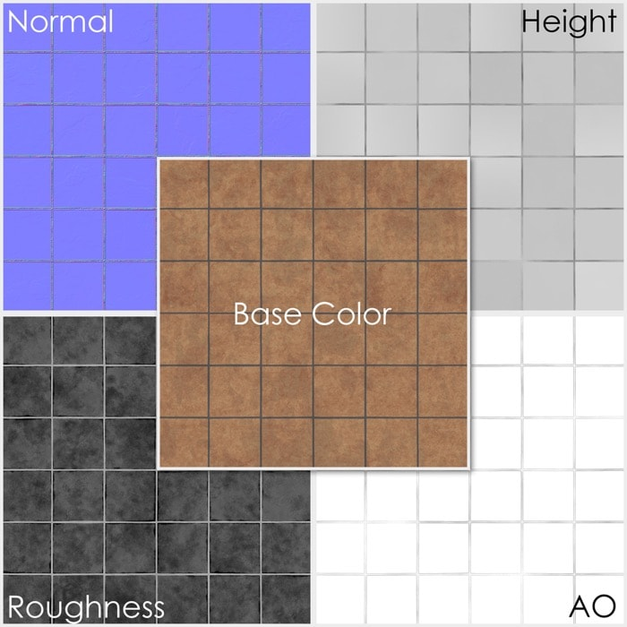

Figure 3. 1 PBR Material Textures

## Visual Programming

Visual programming is a type of programming language that lets humans describe processes using an illustration. Whereas a typical text-based programming language makes the programmer think like a computer, a visual programming language lets the programmer describe the process in terms that make sense to humans. Visual coding tools follow the same processes and paradigms as text-based programming. Imagine drawing a class and its relationship with the objects, users instantiate, rather than typing it all out into a text editor.

This software uses this visual programming method to facilitate user to create procedural textures using graph-based visual programming language toolset. So that the user doesn’t have to have any programming knowledge t create these materials procedurally using a computer.

## Node Based programming

A node-based interface to mostly create texture elements. As with many common scripting languages, it is used to define object-oriented (OO) classes or objects in the underlying C++ engine. Under the hood, these are just C++ functions. Users will use this library of sort and add their own custom-built functions to push it to the next level. Textures can be made procedurally without a single line of code using node-based programming.

Node-based programming is a type of language that is used to run image data through different image processing functions. This could be generating content as in UE4 node networks, applying filters to images, etc. There are very little or even no control flow structures involved here. These nodes carry data about the graph that can recreate the image so that those nodes can be used to recreate the texture file.

## Persisting user-created projects online

The projects that users create can be saved on the cloud or can be shared among the community and get feedback. Users also get the chance to sell or buy these products via the web platform. Since the projects are node-based programming language files, the server will only keep data about what are the nodes used in the graph and parameters used inside those nodes which are sufficient to recreate the image using those data.

# 

# METHODOLOGY

## Overview

The proposed system to provide internet capabilities is implemented according to microservices architecture. There are 7 different microservices that the system made out of.

* Editor Service
* Web Service
* CDN Service
* User service
* Data service
* Post Service
* Redis Cache

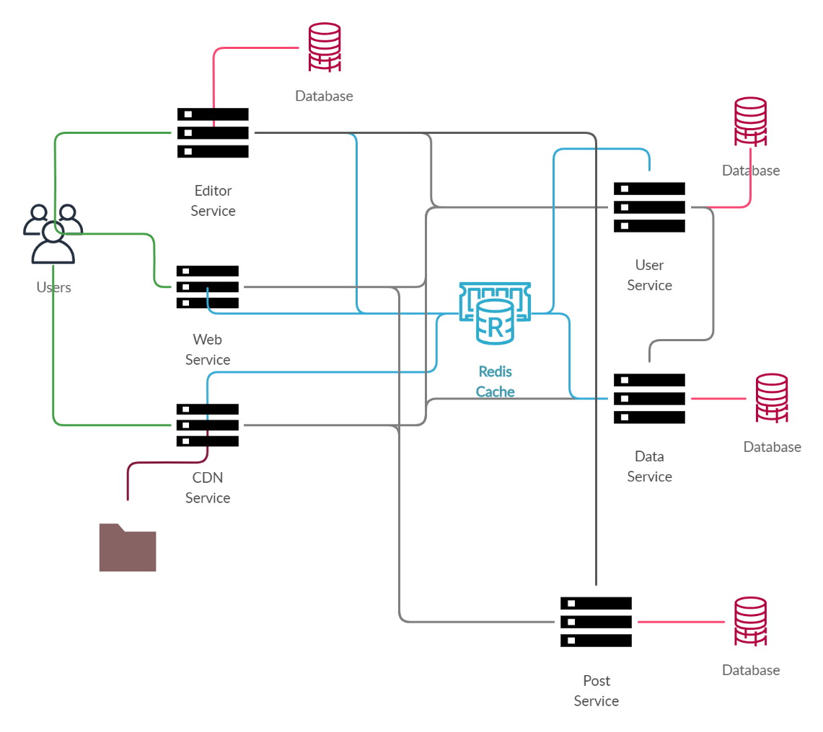

Figure 4. 1 Server Microservices Diagram

### Editor Service

Editor microservice is the service that if a user uses the material designer editor connects to, has the capabilities to log in, logout, sign in and save projects and etc. This service is exposed to the world and inbound traffic originated from outside the system can access this service. Editor service also can issue JWT tokens (both session and refresh tokens). Uses GraphQL connections and WebSockets to connect with end-user software, which is Material Designer Editor.

* + 1. Web Service

Web microservice is the service that the website connects to, this microservice is also exposed to the world and inbound traffic originated from outside the system can access this service. This service doesn’t have a database, but can communicate with other microservices and also manages connections by the users. Also can handle login, logout, sign in, sign out functionalities which originates from the website by users. Uses GrpahQL and WebSockets to connect with the outside world.

* + 1. **CDN Service**

CDN service is the microservice that hold image files, and other metadata to be fetched by the outside world, images and rendered projects users upload will be stored here and users with certain authentication level. Uses API to connect with other services using Axios.

* + 1. User Service

User service holds data about users, their usernames hashed passwords and other private data. inbound traffic from outside the system cannot access this service and only the system services can access this service. Has a database to persist data. Uses API to connect with other services using Axios.

* + 1. Data Service

Project data, Artwork data, and material data are stored here and inbound traffic from outside cannot access this service and only the systems services can access this service. Uses API to connect with other services using Axios.

* + 1. **Post Service**

Post-service holds data of post data such as the number of likes or comments and also public data such as post description and etc. Only can access from inside the service and inbound traffic from the outside world cannot access.

## Requirement Analysis

### 4.2.1 **Use Cases**

Following figure 4.2 is the use case of the server implementation.

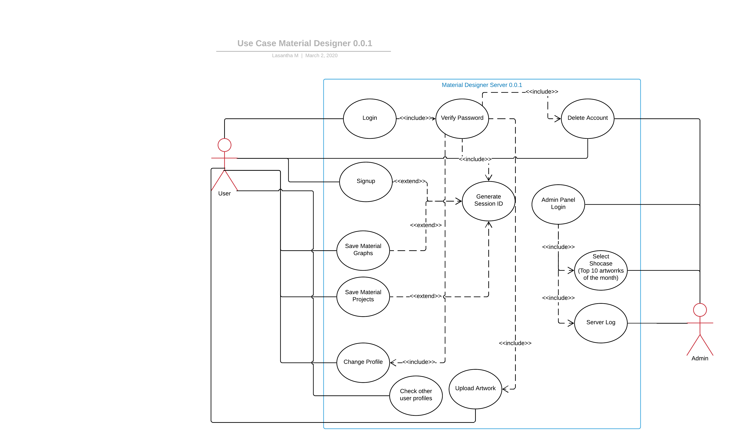

Figure 4. 2 Use case diagram of the server

## **Design**

### 4.3.1 **Class Diagram**

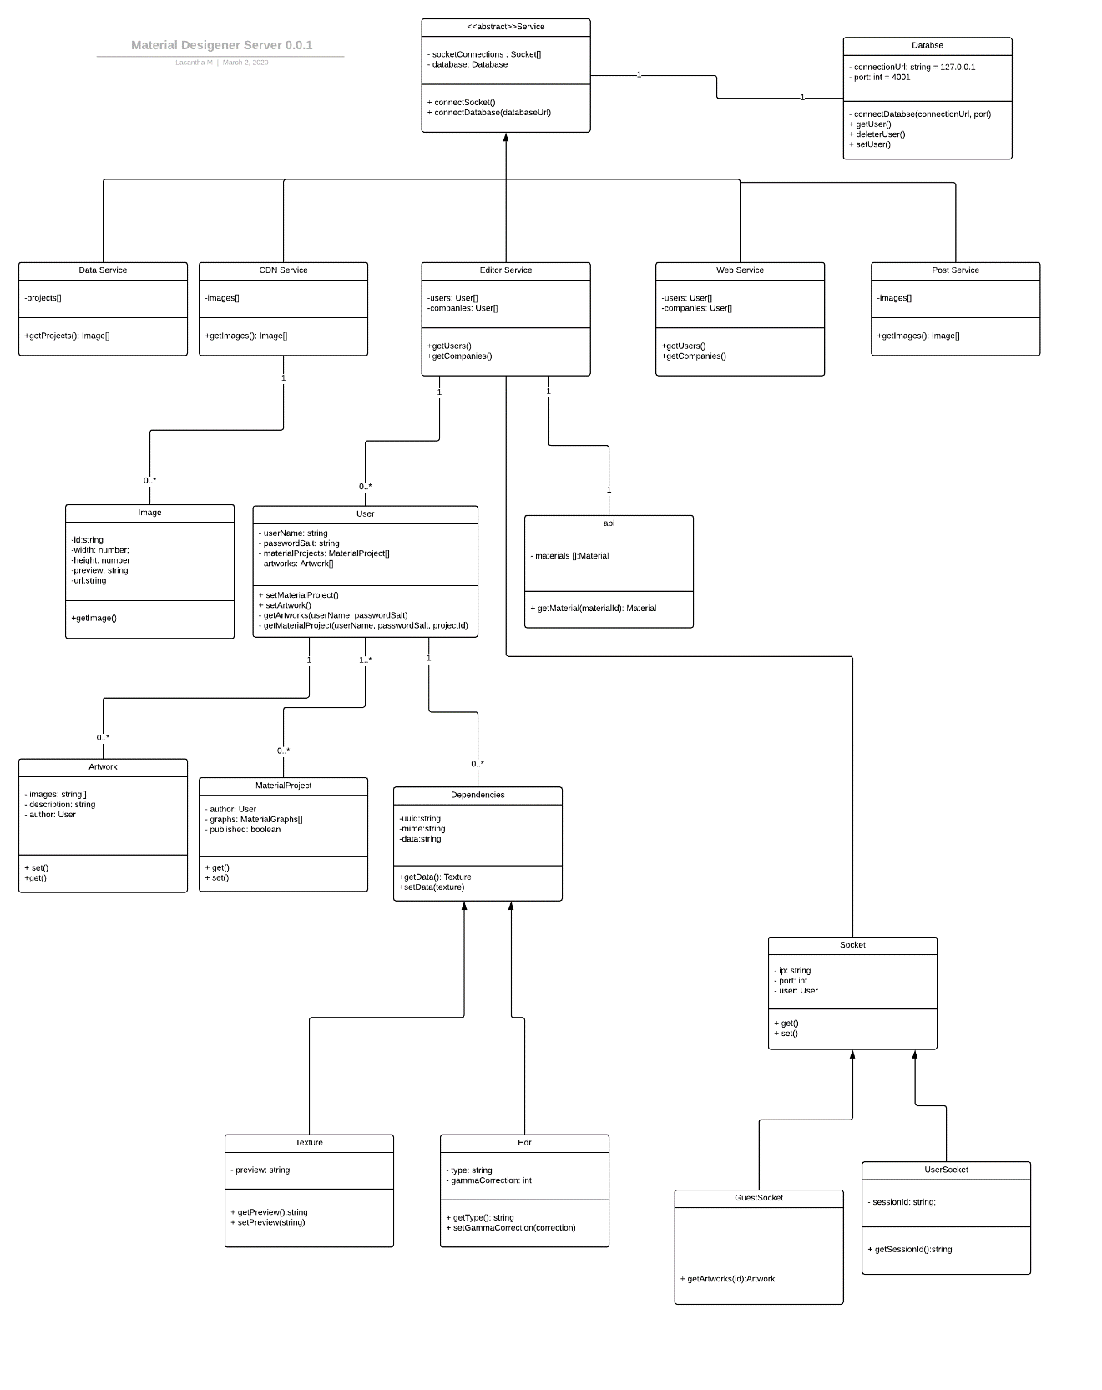

Figure 4. 3 Class diagram of the Material Designer server

### **Package Diagram**

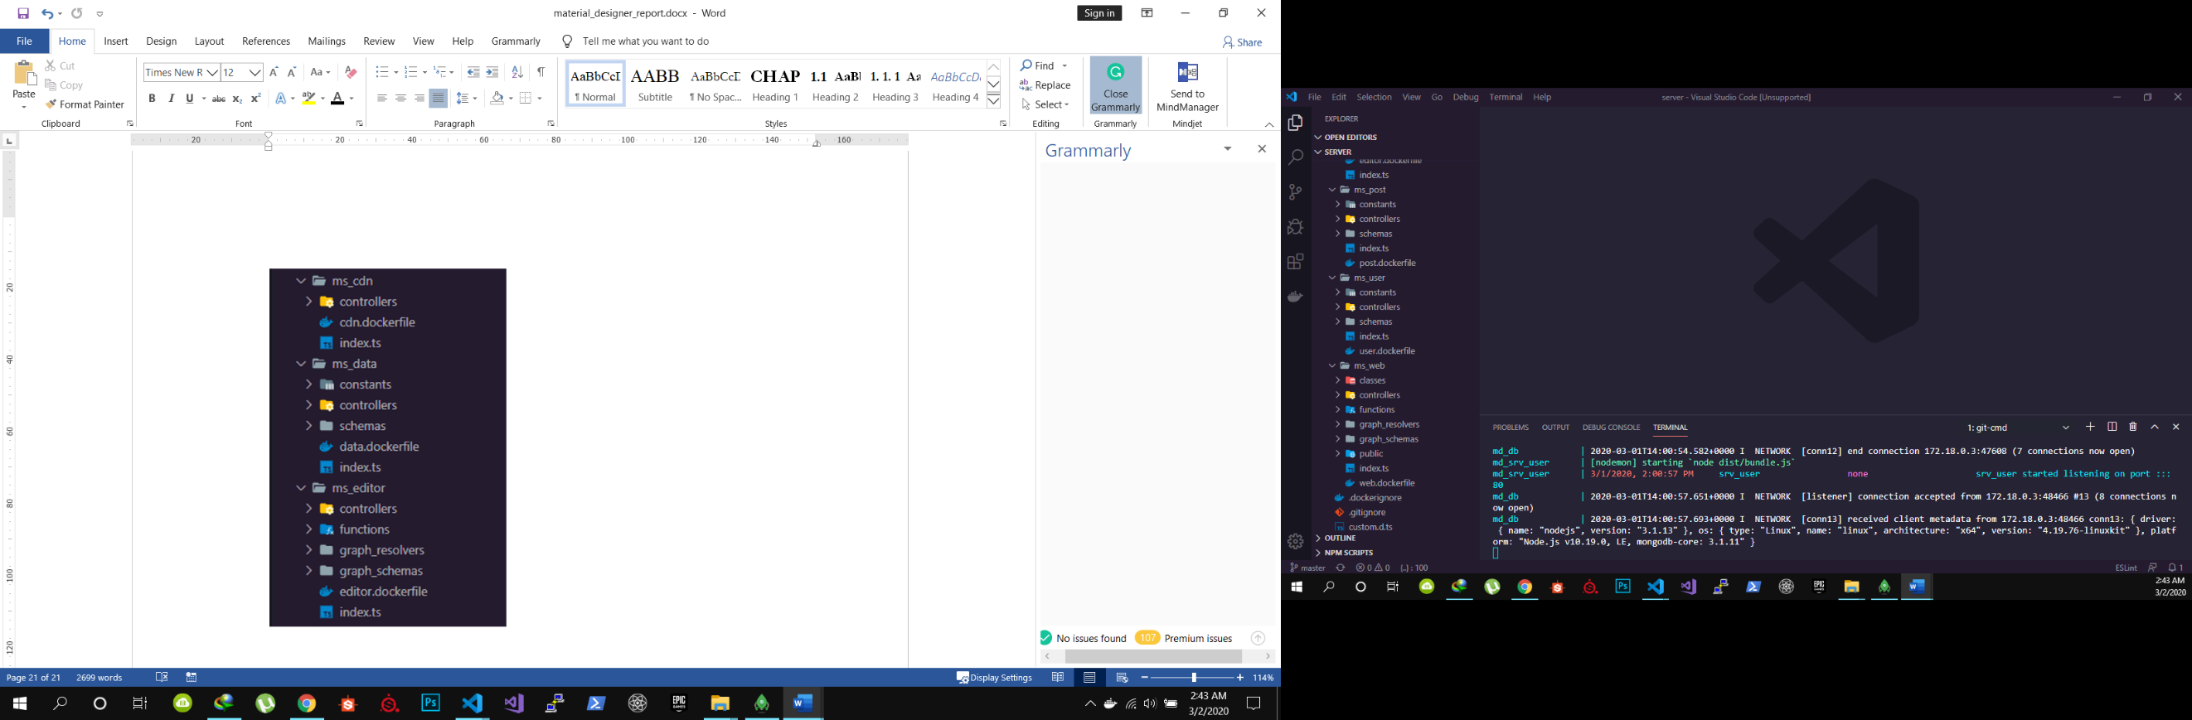

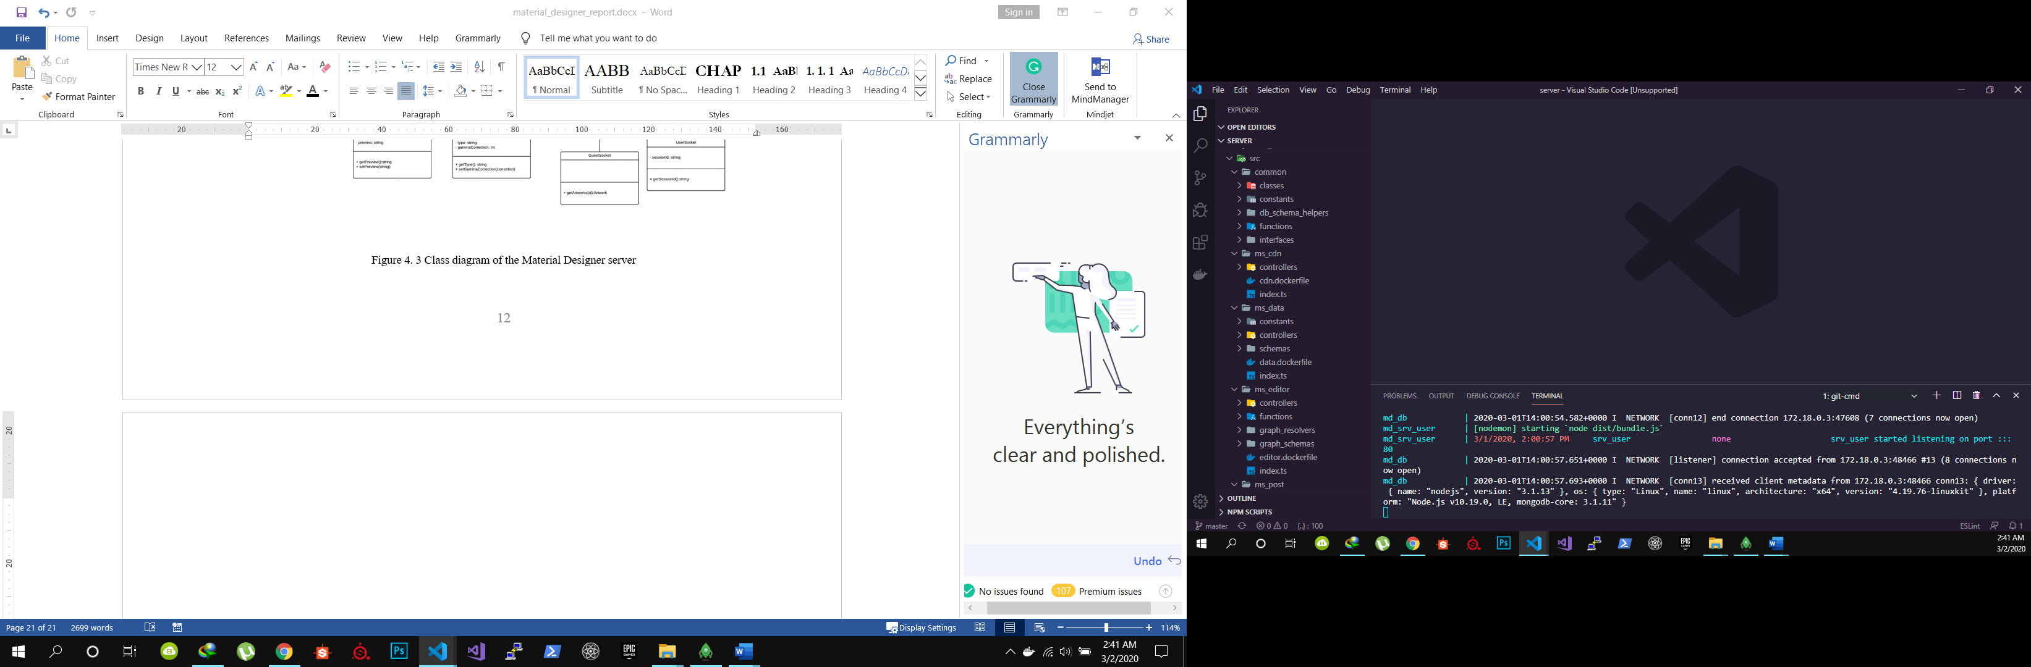

Figure 4. 4 Package Diagram of Material Designer Server

### **4.3.3** **Development Environment**

The material designer server is implemented using the following technologies,

* Docker
* Kubernetes
* Socket IO
* GraphQL
* MongoDB
* Redis
* Axios
* Webpack
* Babel
* Express
* TypeScript
* Apollo-Server
* Jest

Typescript has been used throughout the project since JavaScript is a duck type programming language. Typescript helped in the implementation of the material designer server. Axios have been used to interconnect microservices using APIs.

Docker has been used to implement microservices and As container orchestrator, Kubernetes will be used to deploy the microservices as pods.

Also for the frontend development, the following technologies have been used

* React
* Redux
* Typescript
* Apollo client
* Socket IO client
* Axios
* GraphQL

And for editor software development, the following technologies have been used.

* Electron
* React
* Redux
* Apollo client
* GraphQL and GraphQL subscriptions
* WebAssembly
* WebGL
* ThreeJS
* WebGL Shaders

## Testing Environment

* Deploying environment – Docker Engine
* Operating system – Windows 10
* Web browsers – Google Chrome and Firefox
* Database – MongoDB
* Cache service – Redis
* Front end development – ReactJS with TypeScript

## System security implementation

### Session management using JWT

When a user logs in a user will be provided with a session token which will be valid for only 10 minutes that can be accessed by javascript of the web browser or the editor software. And a refresh token set by the server that cannot be accessed by javascript of the browser or the editor. This has been achieved by setting the “httponly” header of responses. This saves the server from CSRF attacks or XSS attacks by hackers.

### API keys for API endpoints

Users can have their list API keys which let their projects to access material designs via Material designers API. Only who has those keys or the software that request materials with those keys can access those materials using API endpoint.

### Secure Keys

Users who have company accounts can posses a list of secure keys that they can enter to the software they install on computers. And only those computers with those keys can only access company projects via employee account.

### Password Encryption

All the passwords saved in the server have been encrypted using bcrypt which is a battle-tested one-way hashing algorithm that uses Blowfish cipher. This way the even if the server is compromised, sensitive information such as passwords will be protected to some extent.

A salt and a hashed password will be saved on the database which the server can use to verify users when login before issuing session tokens.

### Client and Server-side validation

All the requests originate from the client-side will be validated and check for faults and scripting attacks and all malfunctioning and bad requests will be discarded by the server or by the client. Most importantly all the requests are verified at the server-side.

# 

# RESULTS AND DISCUSSIONS

This section highlights the results of the project together with screenshots of the actions performed in this project.

## System Modules

Here is an overview of modules that the system made out of

* 1. Signup user
  2. Login user or company
  3. Profile Information
  4. Home page
  5. Download page
  6. Top 10 artworks page
  7. Newsfeed
  8. Search
  9. API Key manager
  10. Secure Key Manager

## User Interfaces

### Create cloud projects

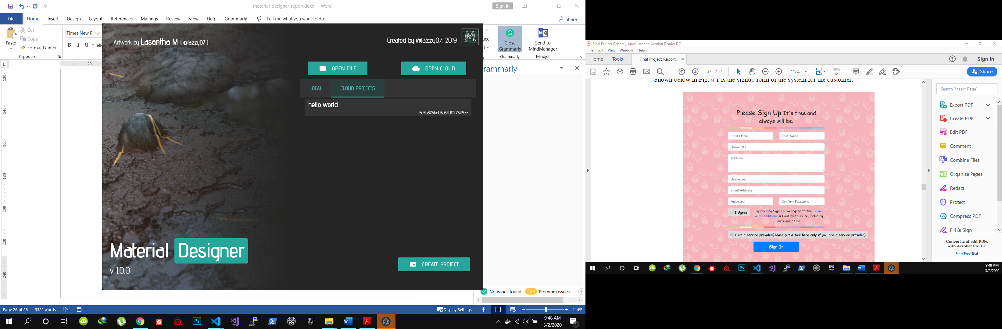

Figure 5. 1 Loading and creating new cloud project files interface

This interface is shown above (Figure 5.1) can be used to create new web projects and immediately the software will connect with the server and create a new project after user validation. Only users that logged-in correctly can access cloud services.

### 5.1.2 Homepage

The homepage is presented to the users who are not logged in so that they can get an idea about the system.

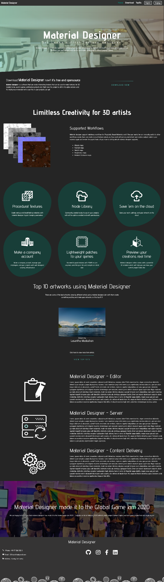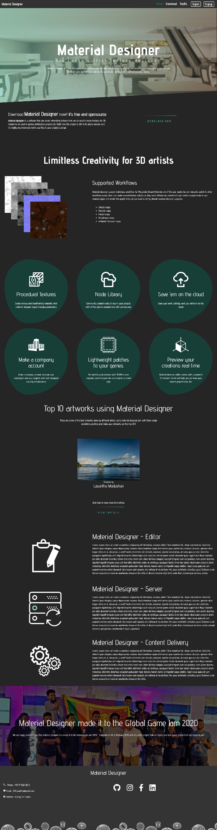

Figure 5. 2 Homepage screen capture

### Download Page

The download page will be presented to the users so that they can download the software and create procedural textures and share them on the system.

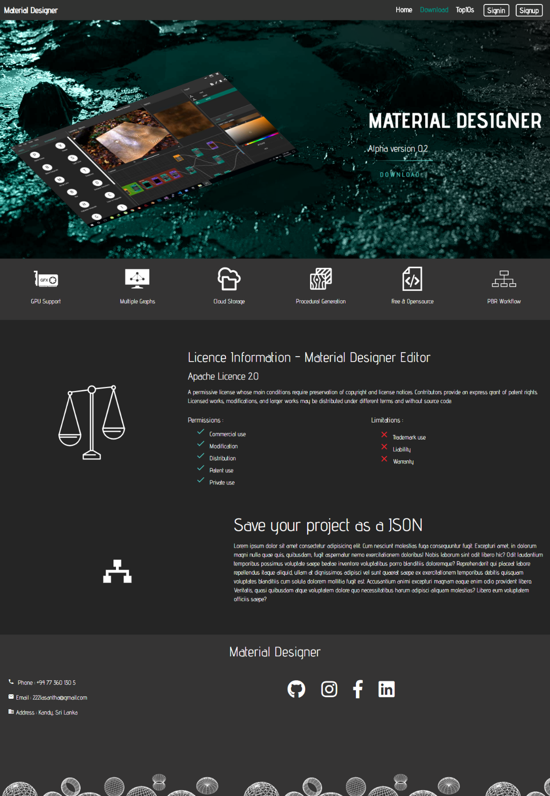

Figure 5. 3 Download page

### Material Viewer

The material viewer can be used to preview user-created material over the web. This has been implemented using WebGL and WebAssembly using ThreeJS.

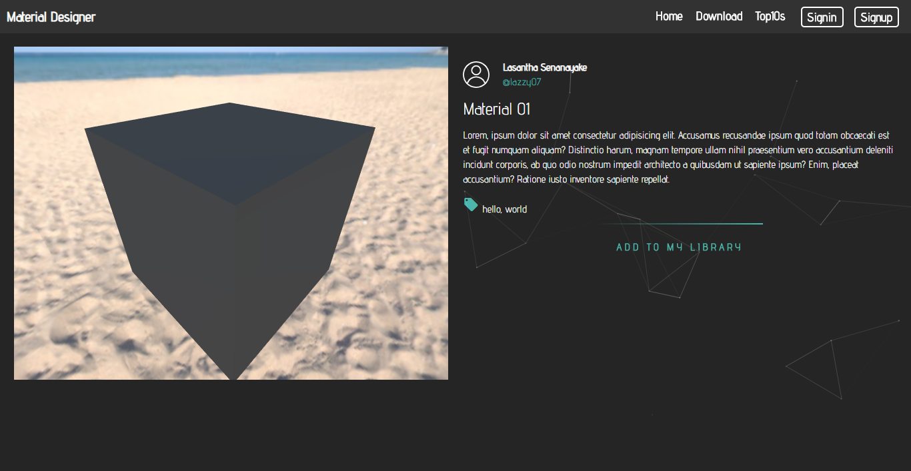

Figure 5. 4 Material Viewer UI

### Material Designer Editor Software

Material designer software can create material graphs using mathematical functionalities and save them in a JSON object and then they can be shared and stored in the system. Users can choose to log in or use the software without login which will turn off web capabilities.

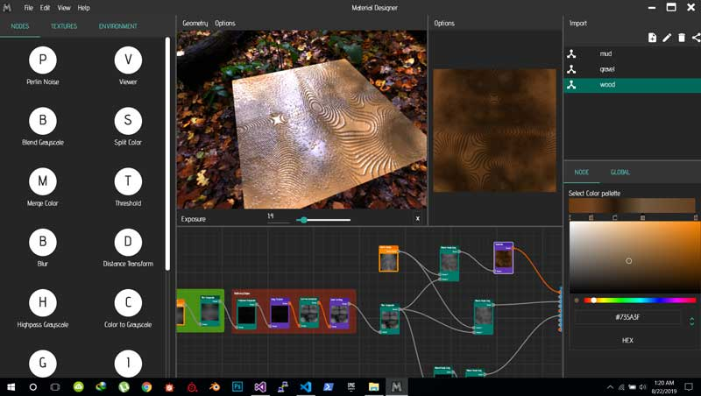

Figure 5. 5 Material Designer Editor UI

### Uploading Artwork / Projects Interface

Users can upload their creations to the server as images to get appreciation and comments from the community. The maximum file size that can be uploaded is reduced to 5MB and a client-side worker will minimize the size of the images that were uploaded. In the server-side, filesize will be checked before saving on the CDN service.

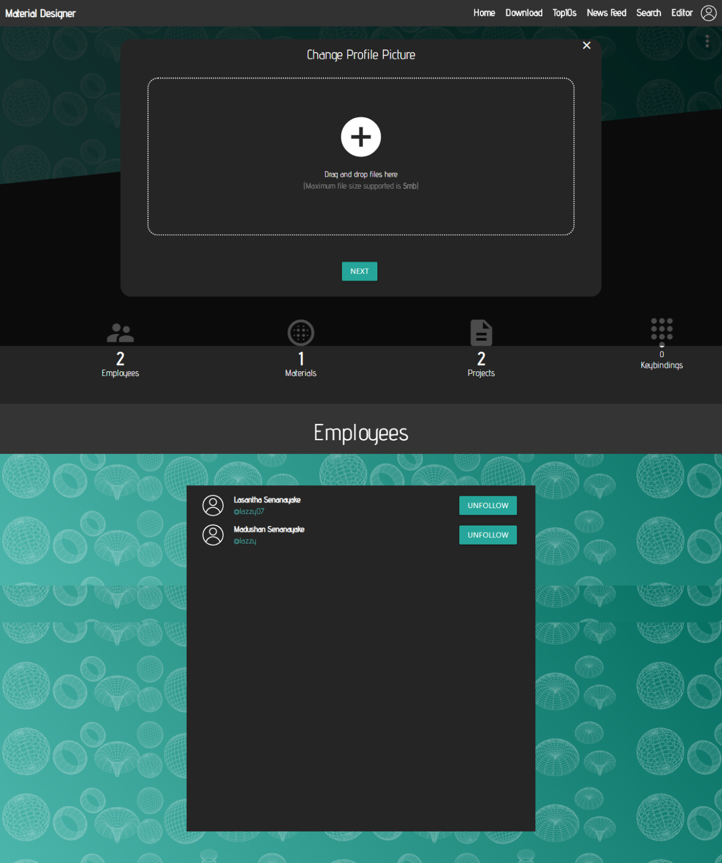

Figure 5. 6 Uploading artwork interface

### API Keys Manager

API keys manager can manage the keys that the user can provide to his own clients to access their own software and games to use user-created materials.

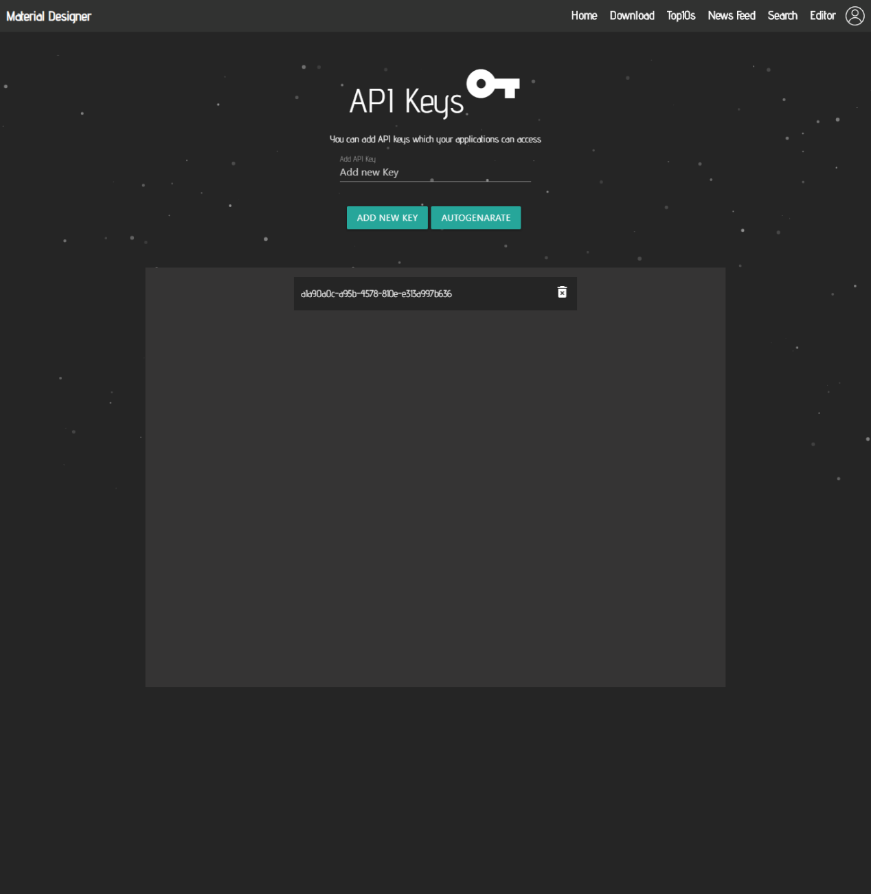

Figure 5. 7 API Keys manager UI

### User Login

Users can use the login interface to log into the Material designer service and they will be provided with JWT tokens that can be used to authenticate and use the service without the need to re log in. client-side and server-side validation will be done in order to keep the service secure

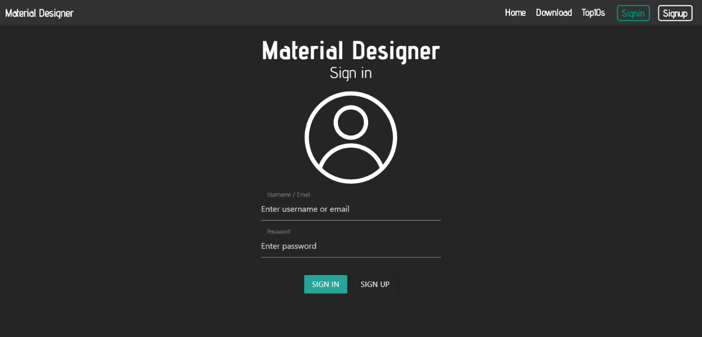

Figure 5. 8 Sign in interface

### Signup Interface

The Signup interface can be used to create new user accounts. Users have two options and they can choose between a company account or a single user account that provides a different set of tools and functionality.

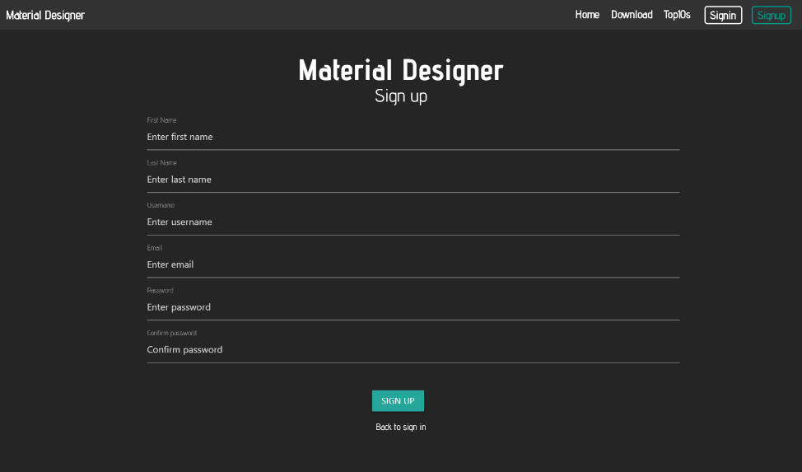

Figure 5. 9 Signup Interface

### Export Material Interface

The export material interface only exists in the software and users can use this interface to upload materials to serve using their API or share with the community. The editor and the website are in sync to capture these changes and update the website in real-time.

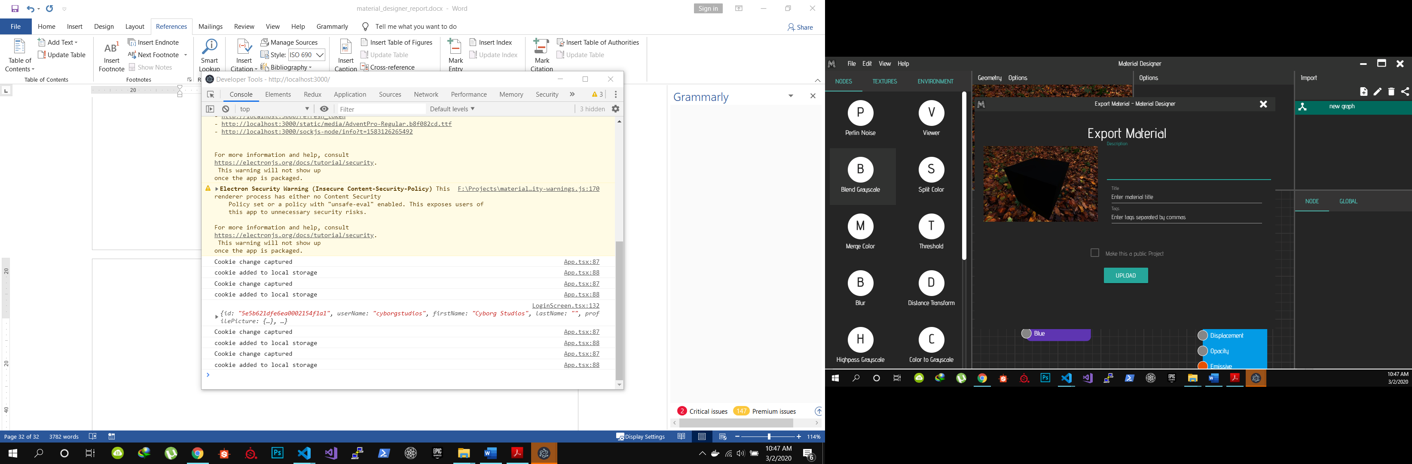

Figure 5. 10 Export Material Interface

### Editor Login

The editor login can use the editor login interface to log into users' accounts and use the functionalities that provided to the users such as saving files on the cloud. client-side and Server-side validation has been done to keep the service safe.

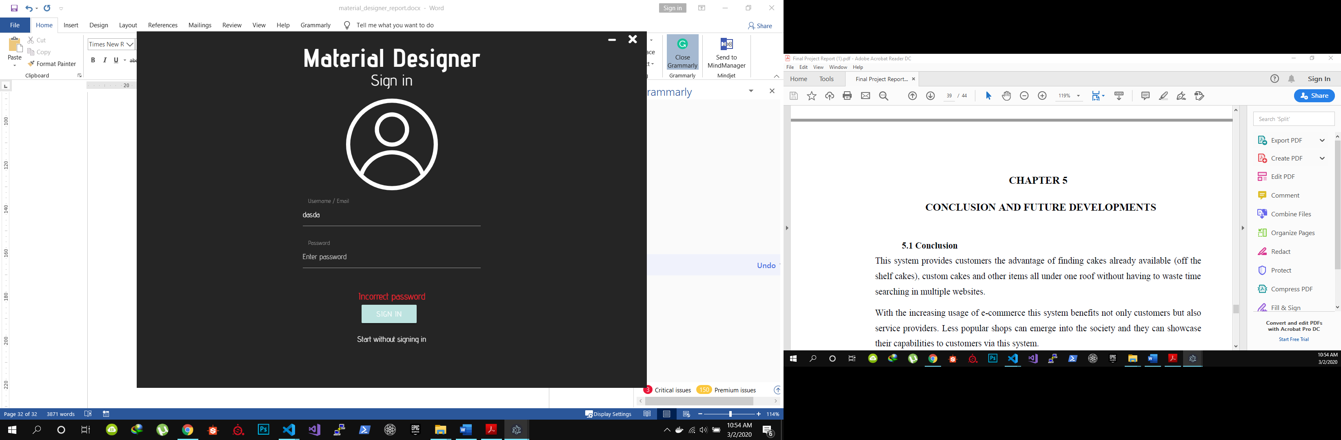

Figure 5. 11 Sign in to editor interface

# 

# CONCLUSION

This system provides users to create edit and also share their creations online with other users and also they can use the CDN facility to use in their own games or graphic related softwares. With the increasing demand for cloud-based software, this system is a great solution to work in a cloud environment.

A system that uses a lightweight texture content delivery system is a newly introduced concept by this project. Especially browser-based games can use this texture content delivery system to get rid of the long loading times and also to use users browsers new WebGL and WebAssembly capabilities to give a great service.

The cloud-based texture creation system that can be used to collaborate among employees for companies is a new concept that also developed in this project which can be used in large scale companies.

# 

# FUTURE WORK

## Future Developments

1. Adding a service with capabilities to buy/sell materials.
2. Security Improvements.
3. User interface and experience improvements.
4. Advanced newsfeed algorithm.
5. AI-based suggestion system.
6. Search algorithm improvements.
7. Keybindings sharing system. Which is a system that can be used to share the keyboard shortcut templates among users.

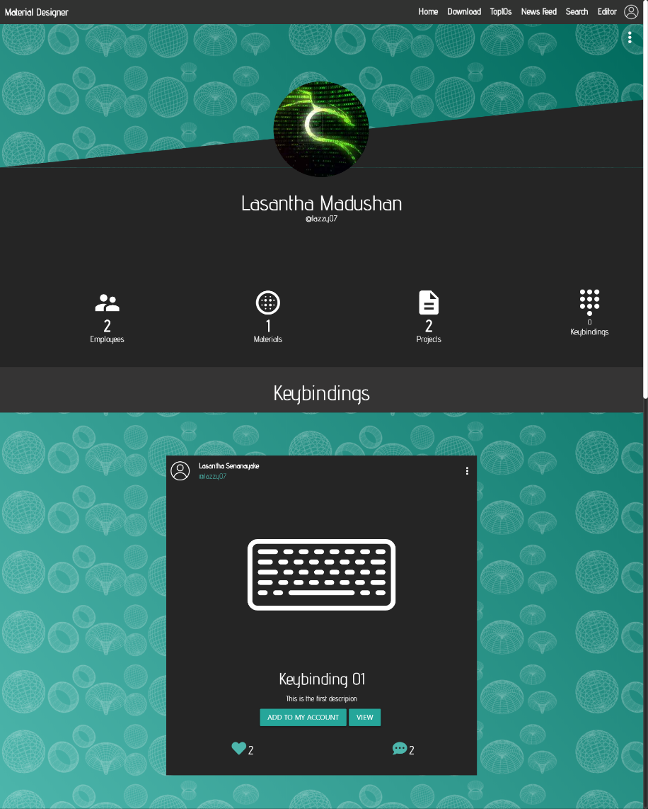

Figure 7. 1 Keybindings Interface

# REFERENCES

[1] Substance Designer. Available at: <https://www.substance3d.com/products/substance-designer/>

[2] Quixel Mixer. Available at: https://quixel.com/mixer

[3] Substance Alchemist. Available at<https://www.substance3d.com/products/substance-alchemist/>

[4] Quixel Megascans. Available at: <https://quixel.com/megascans/home>

# APPENDIX

**Artwork Schema**

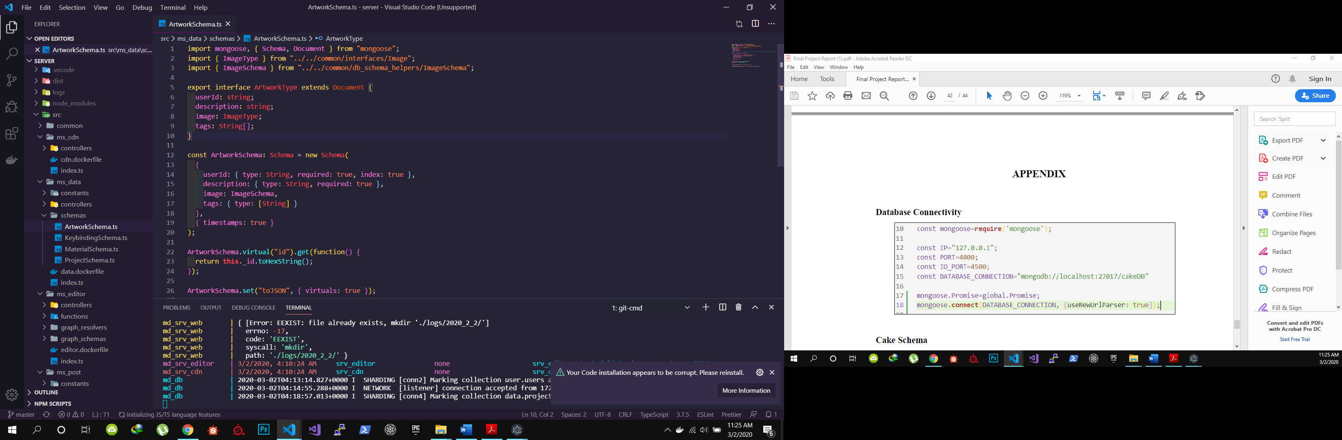

**Material Schema**

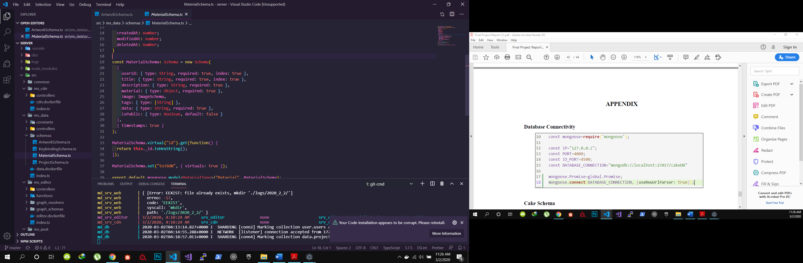

**Project Schema**

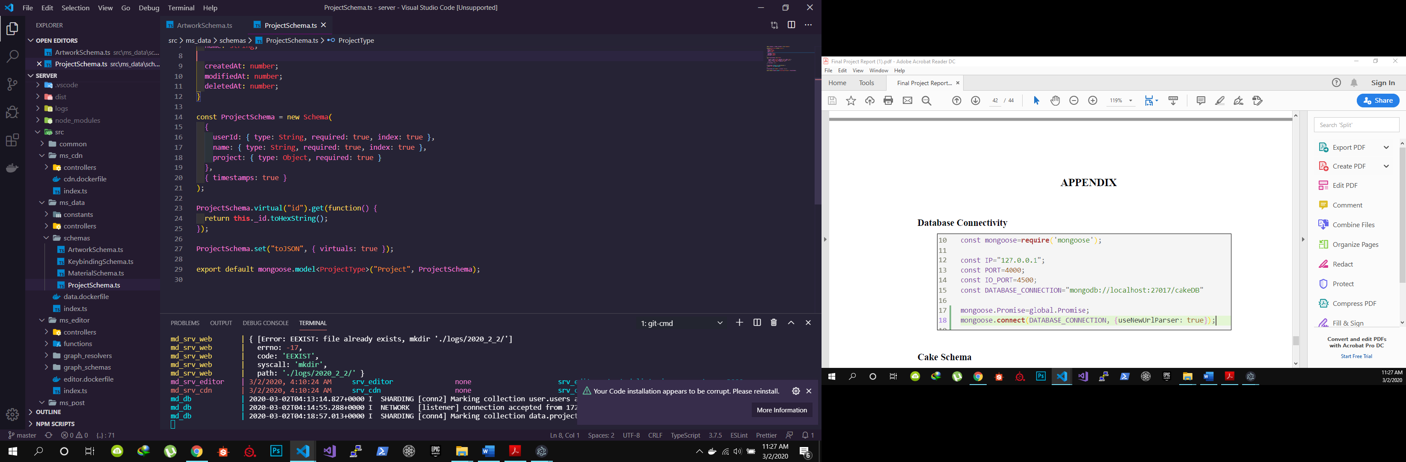

**Post Schema**

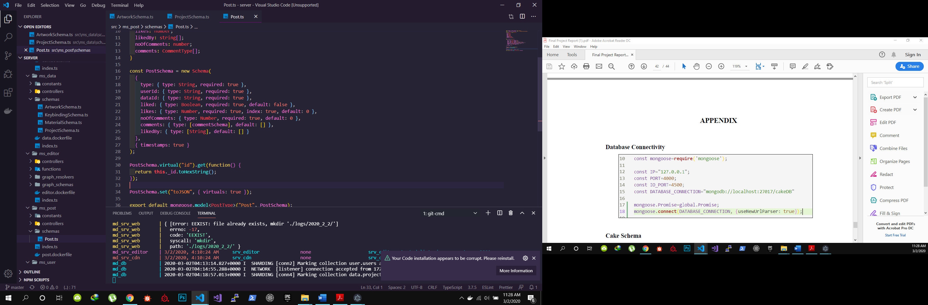

**User Schema**

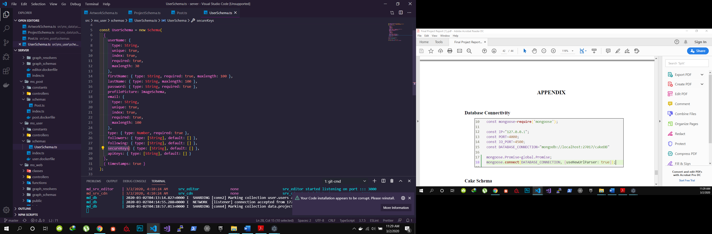

**User Service DockerFile**

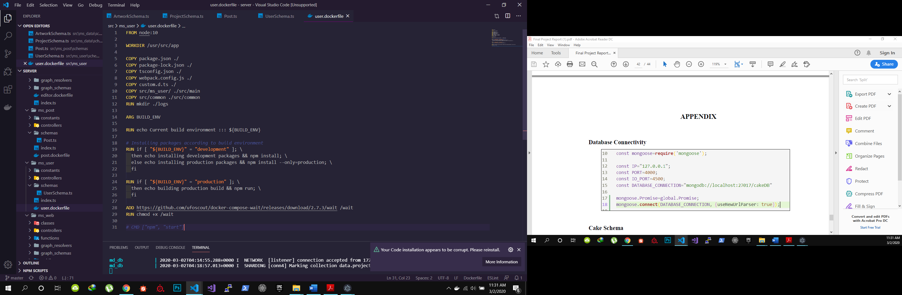

**Docker Compose Configurations**

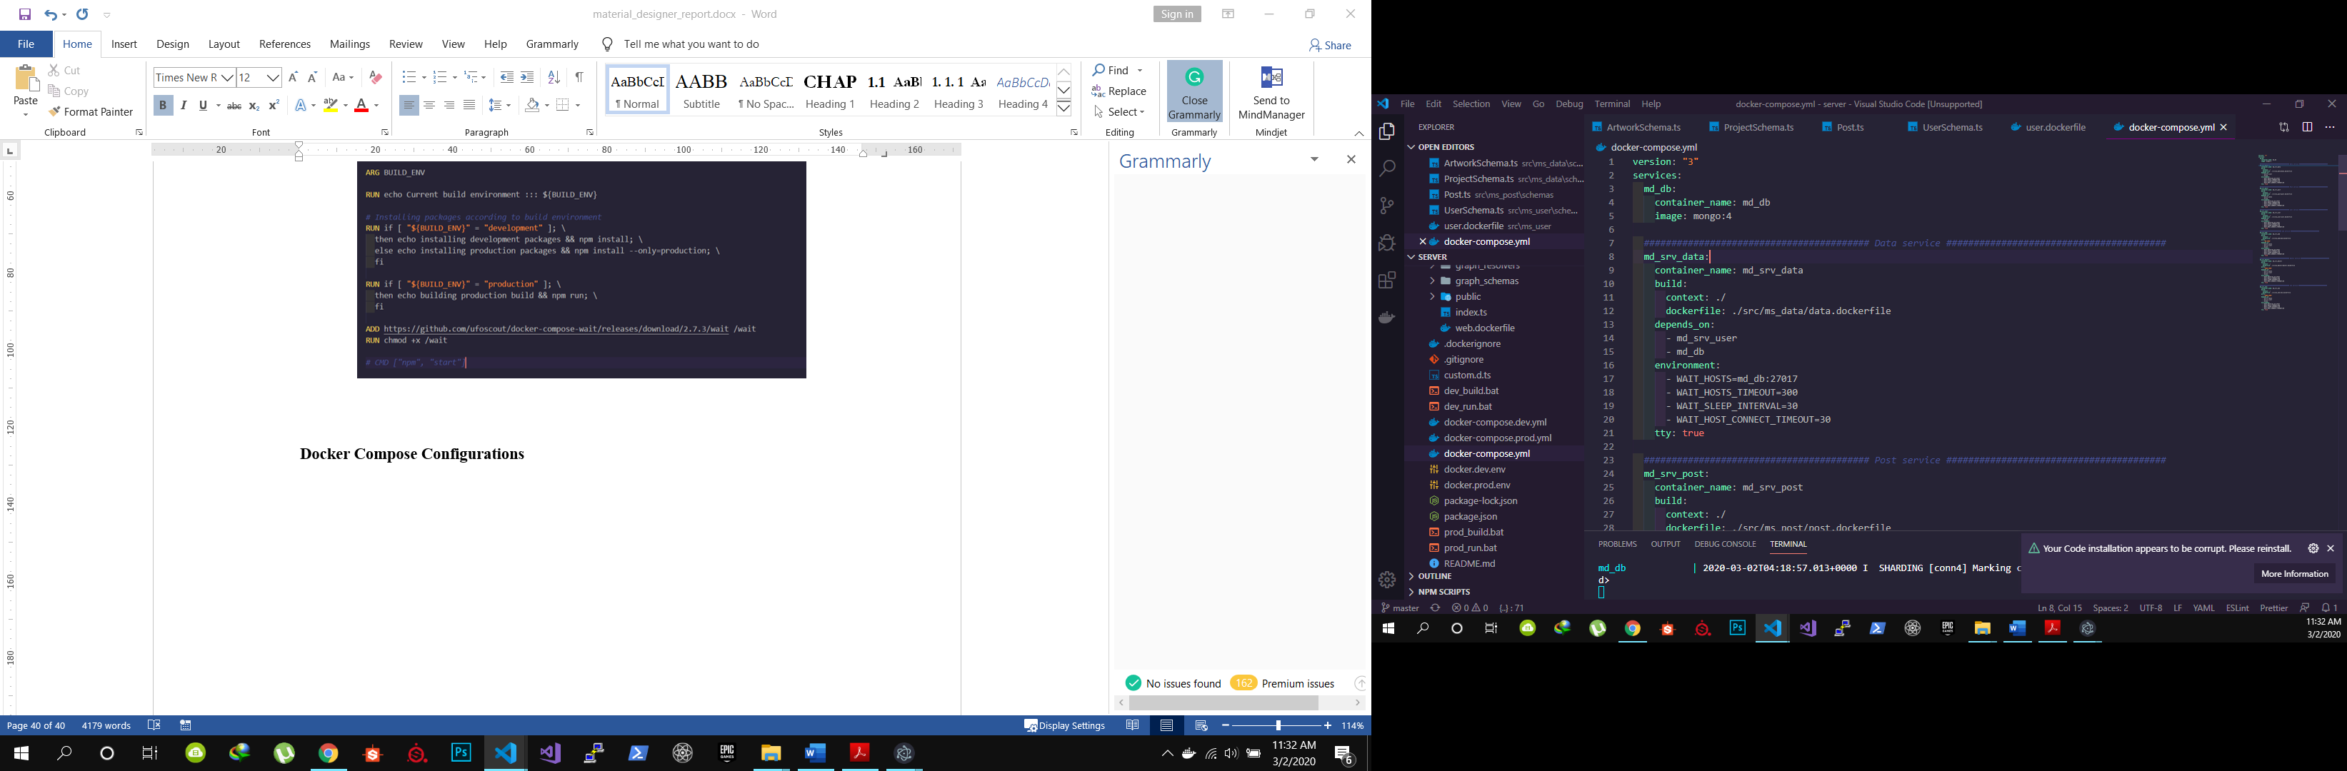

**Docker Containers**

